**Team Members:** Arpit Patel (765762373)

Khushbu Vanikar (712475142)

Priyank Patel (719461071)

Rahul Lachoriya (794861433)

**Project Name:** City Gold Ticket Booking

**Submitted to**: Professor Mark Gilder

**Submitted on:** 05/04/2016

**Part 1: Project Description**

In this fast and changing era, information management and information technology is going to perform an important role to make life better. We are living in the mobile age during past some years. Cell phone revolution enhanced almost each and every aspect of human life and living standard. A Cellphone is laudably suited to handle any type of information and after that the processor takes this information; perform some basic operations and generate an output according the predetermined programs.

City Gold Ticket Booking is a mobile cell phone application, which can facilitate users to book tickets of movies in a multiplex theater. Users will be provided to book their tickets according to their choice of row and column in auditorium. Users can make this reservation according to their time and day. Payment facility is also a main part of this application. User can make a payment online through this application. Ticket Hold would also be provided; in this functionality, user can hold a ticket which he booked and he can pay physically at theater prior 30 minutes of show time.

This project is mainly divided into two modules. First it is Admin and the second one is User module, which is also called member module. In this module, uses an application associated with website of the City Gold Theater.

**Similar Projects**

When I think of this online booking process, standing in a queue and waiting for your turn comes first in my mind. People are sparing a lot of time just to get a ticket in theaters. They have to stand in a queue and that too has a risk of houseful for the show they are looking for. Basically, viewers are investing a lot of time from their hectic life. In many cases, viewers do not get their favorable seats on desired show time. In some situations, they have to compromise in the available seats. Secondly, viewers are facing the same problem while buying beverages and food. So, this is the point when this online booking application comes into an action. This mobile application can book a ticket remotely through Internet. Users have to log in first time and then they will be able to book a ticket. By using this application, user can select the location according his choice. Moreover, user can hold a ticket online. In this functionality, user can reserve a ticket and can pay 30 minutes prior to the show. In addition, user can buy food and beverages online. The condition is that, they have to select a theater they wish to go.

I have noticed some similar functionality in various applications. PVR cinemas and Regal cinemas are frequently used applications for the same purpose. They help to book a ticket online. These applications are showing upcoming movies in near future. They display the information about particular movie. User can buy food and beverages and they can pay online. Moreover, users are directed properly to make payments.

**Why this approach is better?**

While talking about the better approach, City Gold Ticket Booking application has an initial functionality same as other applications have. It allows user to book a ticket online. Moreover, user can select a seat as per his choice. Giving the selection functionality to the viewers can attract customers, and eventually it can gain a business.

Secondly, Users can put their reservation on hold. In other words, they can reserve a ticket and pay before 30 minutes of the show time. Otherwise the reservation is going to be terminated. By this functionality, user can reserve a seat and all he needs to do is just go to the theater physically and pay for it. So, this functionality gives users the reliable way to pay for the reservation.

Thirdly, if user is on random location of the city, and he wants to go to the nearest theater; he only has to do log in to the application. Afterwards, user can find the nearest one and will get the proper directions towards the theater. This functionality gives users a convenient way to find the exact location of destination.

**Technical Challenges**

As this has some new and unique functionality, there might be some technical challenges. Here, technical challenges stands for the difficulties were came up while developing this application. Below is the list of some technical challenges.

* **Seat selection:** It is the most challenging part for this application. When different users are using the application from discrete locations, then synchronization to the server is very important. At this point, seat selection should happen from priority base. So, this is the main challenge fro this application.
* **Payment Gateway:** Payment gateway is the feature, which runs on the time of payment. Viewers are using this feature while paying for the services they are using. The challenge can arise for the authentication of the customer card’s number and CVV (Card Verification Value) code authentication. Payment gateway connection can possible this feature, so this can be a challenge on technical aspects.
* **Location Accuracy:** Location accuracy needs to give an output to the users each and every time they fire a search button for the nearest location of the theater. GPS can do it fluently, on condition that users have to be connected to the Internet. If user loses Internet connection, then it would display the proper error message from the server.

**Part 2: User Analysis**

As this application is more concerned about the theater and booking a ticket, so all the tasks are divided by the category of the users. There are mainly two categories of users. First, it is admin. Second, it is end user.

1. **Admin:** Admin can perform various tasks. Admin can add and remove the logical contents, which are directly connected to the services given by the application.

* Admin can add and remove the movies whichever he wants. He also can change movie trailers and promotional offers as well.
* Snacks in the Food & Beverages section can be altered by the admin.
* Admin has an authority to allow users and delete the account.
* Payment gateway and GPS locater can be handled by an admin.

1. **End User:**  End user can be of any age, and it can be a technical or not technical person. User can be of any profession. It can be a student, family person, doctor, engineer, and etcetera. Here is the common list of the task, which can be performed by the end user.

* Creating an account and signing in is the initial functionalities of the end user.
* End users can select a movie they wish to watch.
* Users can see the videos of upcoming movies.
* Users can book a ticket and also they are allowed to select a seat.
* Payment gateway is also considered as a task, which can be performed by the end user.
* User of this application can find the nearest located theater from his current location.

**Personas**

* Persona for admin: Here, is the persona by which the user task analysis can be cleared. Its functionality can elaborate the feature is added to the application.

1. Michael is a system admin for this application and suddenly he came to know that Captain America is going to release very soon. So, he is adding a movie name and trailer into upcoming movies section of the application.

* Persona for end users:

1. Jack is a college student who has taken a transfer from Log Angeles, CA to Dallas Texas. He wants to watch a movie but he doesn’t know the perfect location of theater. He needs to log in to this application and can use the GPS locator to find the nearest location of theater.
2. Ronny is trying to book a ticket from his way to theater. He already booked it and wants to eat some beverages. He can do it with use of this application under F&B section.

**Part 3: Task Analysis**

This system has several tasks, but while categorized them; they can be two types.

1. Admin tasks
2. User / Customer tasks

**Task Analysis for Admin**

**Task 1:** Sign In

Admin can log in with valid user name and password.

**Task 2:** Contents Changes

Admin can make changes in the movies section. He can add new movies with ticket rates and its contents.

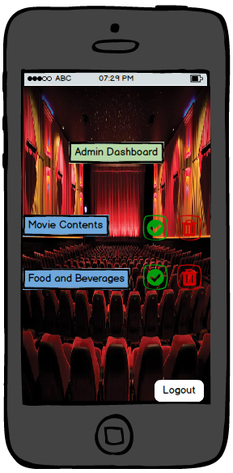 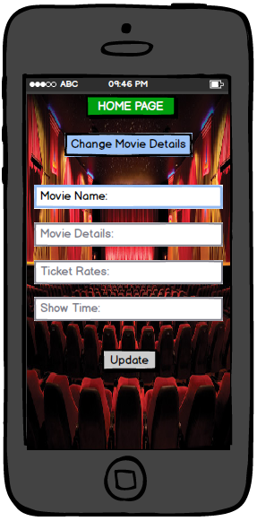

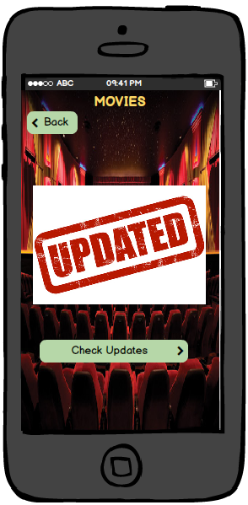 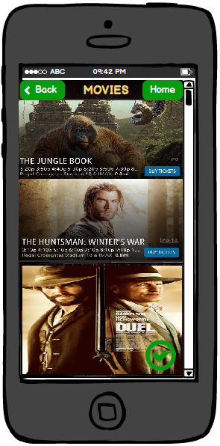

**Precondition for this Task**: Admin must be log in with initials.

**Step 1:** Admin should select ‘Movie Contents’ option.

**Step 2:** Then he can add movie name, ticket rates, detail and timings for show.

**Step 3:** By clicking on the ‘Update’ option, he can make changes.

**Step 4:** Next step will show the changes made by admin.

**Task 3:** Changes in Food and Beverages

 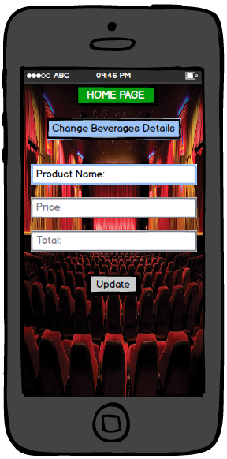

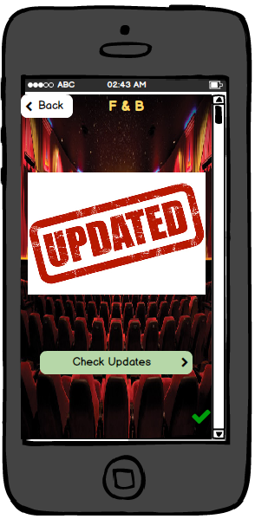 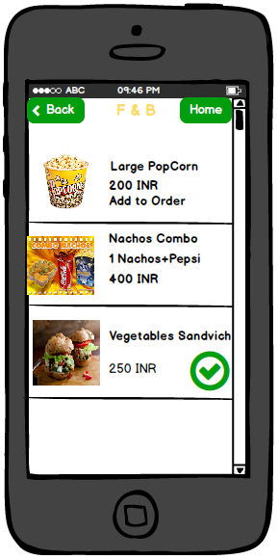

Precondition: Admin needs to get log in to the system.

**Step 1:** Select Food and Beverages Section on Admin dashboard.

**Step 2:** Select update button.

**Step 3:** Update the item mane, price and total.

**Step 4:** Next page will display the changes you made.

**Task 4:** Delete the contents of pages.

**Precondition:** Admin user has to log in to the system with valid username and password.

**Step 1:** Select Food and Beverages section on Dashboard.

**Step 2:** Make a selection of Delete button.

**Step 3:** Select Check box you wish to delete.

**Step 4:** content will be deleted in main list.

 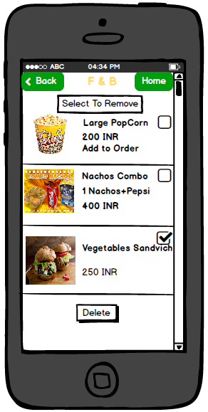

**Task Analysis for End User / Customers**

**Task 1:** Booking a Ticket

**Precondition:** User has to sign up into the system with valid username and password.

**Step 1:** By logging in, user will be redirected to the home screen.

**Step 2:** Select a ‘Buy Ticket’ option on home screen.

**Step 3:** Select the number of tickets. In addition, make the selection of number of Adult, Senior and Children.

**Step 4:** Make a selection of the desired seat in auditorium.

**Step 5:** Select Payment method; and then enter Email Id, Name on the card, Card number, and CVV (card security code) of the card. There is an option for expiration date of card which is also necessary to select.

**Step 6:** You will have two options now. ‘Hold’ will put your tickets on hold.

**Step 7:** ‘Pay Now’ option will redirect you on payment gateway page.

**Step 8:** Your tickets will seem to be confirmed.

**Task 2:** Creating a Profile

**Preconditions:**

* User must be log in to the system with username and password.
* Select a Menu Button, right most upper corner.

**Step 1:** Click on ‘Settings’ button.

**Step 2:** Click on ‘My Profile’ button.

**Step 3**: Enter User Name, select appropriate sex, and enter your Email address and password.

**Step 4:** Click on save option.

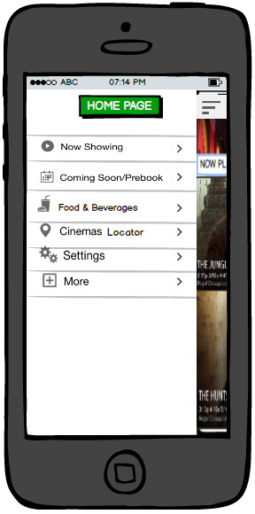 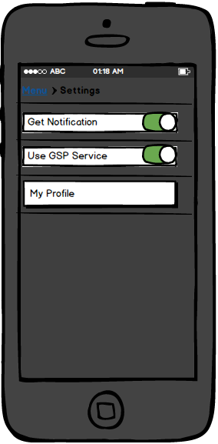

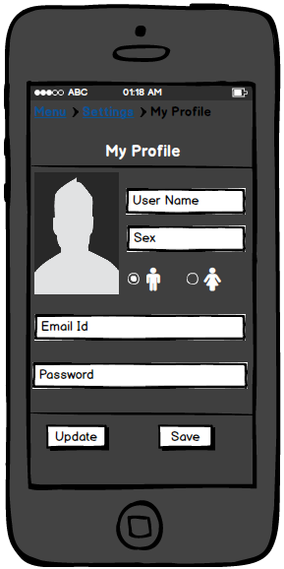

**Part 4: Domain Analysis**

Domain analysis contains each and every entity of the system. In other words, it explain which contains are active in the application. This system contains mainly three types of objects.

1. People: This category has end user objects.

* Administrative Users
* End Users

1. Physical Objects

* Cell phones
* Credit/Debit cards

1. Information object

* Log in account
* Videos
* Ticket booking
* Ticket confirmation
* E-mail

Below diagram shows the hierarchy of the system which shows the stack of objects. These objects are demonstrated as per their categories.

D:\Study\StRose\Spring2016\UI\assignments\UI Assign 5\UI Domain Analysis.png

**Domain Analysis:**

This diagram demonstrates the relation of every objects with each other. And how their tasks are connected and affects to other processes.

C:\Users\Arpit\Downloads\Untitled Diagram (3).png

Domain analysis shows the relation between each components. It explains the description of each components.

1. Admin can make or generate an account of users. Admin can remove or add a new account.
2. Admin can update the contents, which are visible on the user ends. They can be added or removed by the admin side.
3. End user can create and account and with the same account user can log in to the system.
4. After logging in, end user can book a ticket. In the same section, user can make a selection of the seat and pay in the same task.
5. End user can order food and beverages and pay.
6. End user can see the upcoming movies’ trailer and detail.
7. User can drop some feedbacks over the movies. It is about the likes and dislikes of the movies.

**Part 5: Scenario Definitions**

1. **End User/Customer**

* Johnson has done with this studies in masters. He got a job into Ahmedabad city. So, he shifted from Mumbai city to Ahmedabad.
* Johnson wants to watch a movie in weekends. But, he doesn’t know anything about the theater, show timings and ticket rates.
* He is thinking of watching a movie in City Gold Theater. So, he is just taking out his cell phone and open a City Gold Application.
* He is looking for the nearest City Gold Theater, by Theater Locator through this system.
* After this, he is looking forward for the Now Playing movies in the system.
* He clicks on Buy Ticket option of particular movie.
* Then after, he will be able to choose number of tickets and number of adults.
* Then he can select his seat in the auditorium.
* After seat selection, he is heading to the final step of the task, which is payment method.
* After making a payment, he would got the confirmation page, and confirmation e-mail on his valid email address.

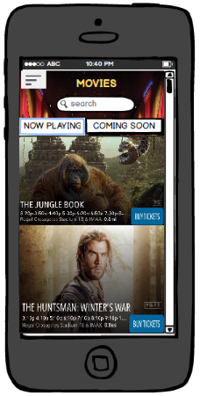 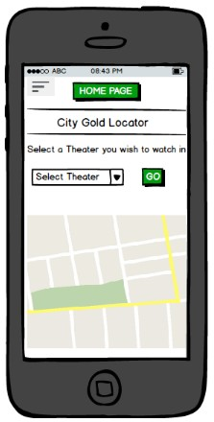

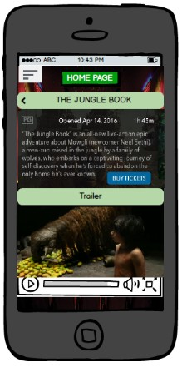 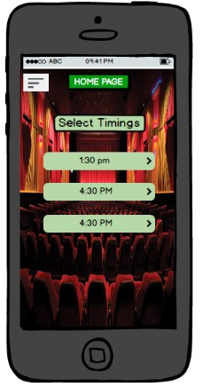

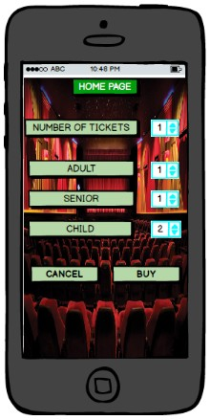 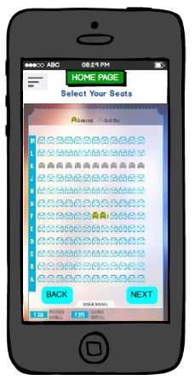

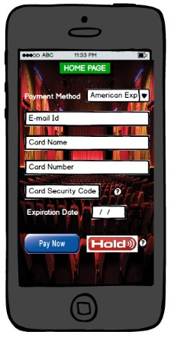 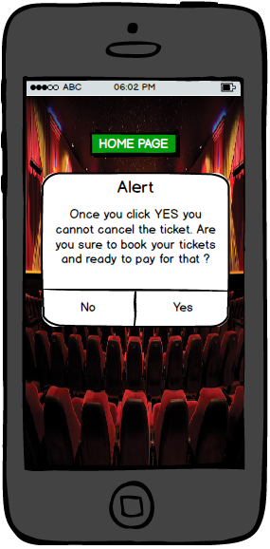

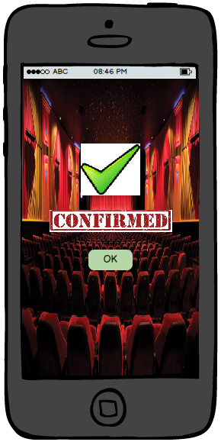

1. **End user/Customer**:

* Gogoleen is a frequent customer of City Gold. He has booked couple of tickets.
* He is thinking to grab some food during show timings.
* He just open an application; And opened a Food and Beverages section.
* Then he is going to select his favorite snacks. He selected tacos and soda combo.
* After that, he proceed further to pay for the total amount.
* At last, he got a final amount to be paid.
* He is about to receive a confirmation about the food. Only thing he needs to do that, food must be collected from the food court.
* He enjoyed movie with snacks without standing in a queue.

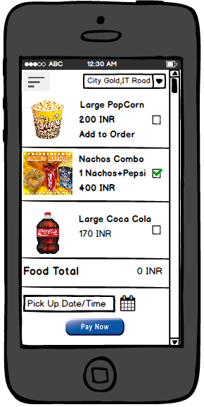 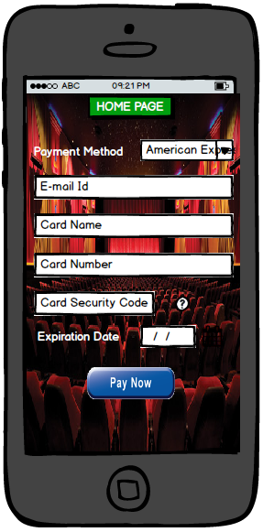

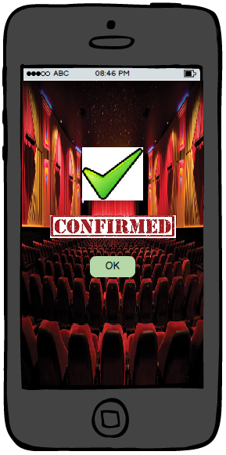

1. **Admin:**

* Ronny is an admin of this system. He wants to change the contents in the food and beverages section.
* He can log in to the system by valid user name and password.
* He is redirected to the dashboard. After this, he has to select food and beverages section.
* Under Food and Beverages section, he is going to delete button, which is animated with a red button.
* Then on next page, he has to select a content he wish to delete.
* After that, he can save changes and will be redirected to the next page.
* It will show up the changes he made.
* This changes will be refreshed on the end user system.

 



**Part 6: Wireframes / Prototype**

Here, I am going to describe 4 UI topics which we studied in the class, and also I will mention, where did I used these topics in our project.

1. **Breadcrumbs**: We have used breadcrumbs in the menu section called settings. We used to navigate the pages; and for that we used breadcrumb on the My Profile page.

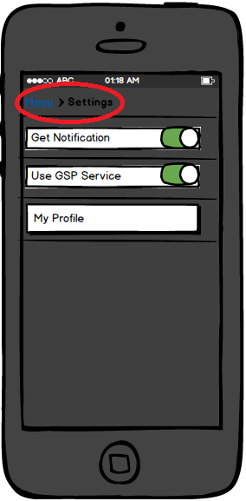 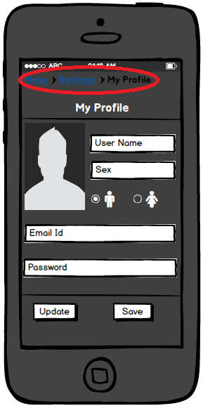

1. **Alert Box / Error Control:** Error control or Alert box shows show the warning of confirmation before proceed further. We used this alert box before customer makes his payment for tickets. So it can prevent some accidental events to be occurred.

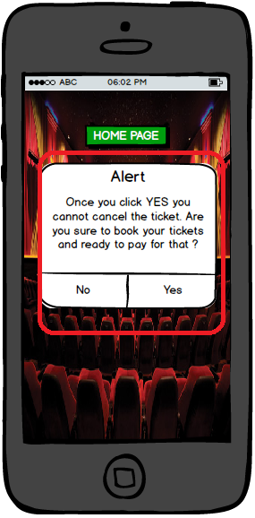

1. **Direct Manipulation**: Direct manipulation can be used to see the extra contents of the same screen. Scroll bar is the example of direct manipulation which we used in our project.

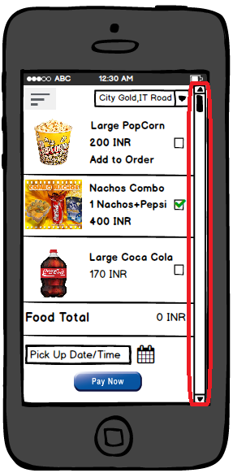

1. **Visibility of Actions**: Visibility actions gives the focus to the button or link which is currently in used. So we used this action on the main home page. There are two separate buttons named “Now Playing” and ”Coming Soon” which have the focus where they are all clicked. So it shows the focus when in use.

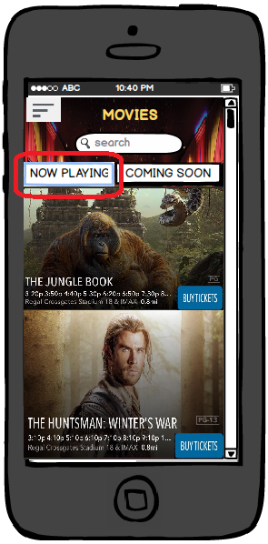 

Here is the link for the wireframes. So you can easily observed all the supportive mock up frames we created for the project.

Link 🡪 <https://strose.mybalsamiq.com/projects/csc505-s16-x2-group6/grid>